

DB Log Clearing and Alert log rotation
All Non Prod Environment

Project



DISCLAIMER

This document is strictly private, confidential and personal to its recipients and should not be copied, distributed or reproduced in whole or in part, nor passed to any third party.

Version history
Date | Version | Description | Author
2020-06-27 | 1.0 | Initial Version | Ajithraj Thangaraj

Contents
Version history 3
1. Introduction 5
2. Background info 5
3. Automation Scripts 5-2
3.1: DB Log Clearing script 5
3.2: Alert log rotation script 6
4. Scheduling automation script through OEM job 8
5. Output Log 14

Introduction

Database generates lot of trace files, xml files, audit files and increase of alert log based on the transaction in the database, this needs manual effort of cleaning up to keep the filesystem on threshold value, to avoid this manual effort, automation scripts are scheduled through OEM jobs that avoid manual invention and take care when it crosses the threshold value of filesystem.

Background info
This Automation script will be scheduled on the below version of Linux environment.
Red Hat Enterprise Linux Server 7.8 (Maipo).

Automation Scripts.

3.1: DB Log Clearing script : These script deletes the audit and trace files of all the databases in the server which are older than 30 days and provides the details of total and available size of the filesystem before and after clearing the DB log files.
#!/bin/bash
###################################################################
#Script Name : DB Log Clearing script.sh
#Description : This script will clears the old DB Log files.
#Author : Thangaraj Ajithraj
#Email : Infosys-Ettsak-Infra-Team@lansforsakringar.se
#
######################## VERSION ##################################
# 1.0 - Ajithraj Thangaraj - 2020/06/27
###################################################################

export ORACLE_BASE=/u01/app/oracle
export ORACLE_HOME=/u01/app/oracle/product/12.1.0/dbhome_1

TotSize=`df -kh /u01 |grep "u01"|awk '{print $2}'`
AvailSize=`df -kh /u01 |grep "u01"|awk '{print $4}'`

echo "ORACLE_HOME size before cleanup:"
echo "Total /u01 file system size: $TotSize and available space: $AvailSize"
echo " "

find $ORACLE_HOME/rdbms/audit/ -type f -mtime +30 -name '*.aud' -exec rm -f {} \;
echo "Deleted audit log trace files older than 30 days"

find $ORACLE_BASE/diag/rdbms/*/*/trace -type f -mtime +30 -name '*.tr*' -exec rm -f {} \;
find $ORACLE_BASE/diag/rdbms/*/*/alert -type f -mtime +30 -name '*.xml' -exec rm -f {} \;
echo "Deleted 30 days older oracle database trace files from ORACLE_BASE"

TotSize=`df -kh /u01 |grep "u01"|awk '{print $2}'`
AvailSize=`df -kh /u01 |grep "u01"|awk '{print $4}'`

echo " "
echo "ORACLE_HOME size after cleanup:"
echo "Total /u01 file system size: $TotSize and available space: $AvailSize"

echo " "
echo "Execution completed successfully!!!"
3.2: Alert log rotation script: These scripts checks the size of all the alert logs of the databases in the sever and rename the alert logs which are greater than 1MB with system date and gzip the file.
#!/bin/bash
###################################################################
#Script Name : Alert log rotation script.sh
#Description : This script will roates the Alert Log of the databases which croses the threshold value.
#Author : Thangaraj Ajithraj
#Email : Infosys-Ettsak-Infra-Team@lansforsakringar.se
#
######################## VERSION ##################################
# 1.0 - Ajithraj Thangaraj - 2020/06/27
###################################################################

db=`ps -ef|grep pmon|egrep -v "ASM|grep"|awk '{print $8}'|cut -d "_" -f3`
for ORACLE_SID in $db
do
export ORACLE_SID
ORACLE_HOME=`cat /etc/oratab| grep $ORACLE_SID|cut -f2 -d ':'`
export ORACLE_HOME
Log_Path=$(${ORACLE_HOME}/bin/sqlplus -S "/ as sysdba" <<EOF
set heading off
set feedback off
select value from v\$diag_info where name='Diag Trace';
exit;
EOF
)
ALERTLOG=$Log_Path/alert_$ORACLE_SID.log
echo " "
echo "Checking the size of ${ALERTLOG} file "
SIZE=`du -sm ${ALERTLOG}|awk '{print $1}'`
if [ "$SIZE" -ge 1 ]; then
mv ${ALERTLOG} ${ALERTLOG}.$(date '+%%d-%%m-%%y')
echo "Current size of ${ALERTLOG} is more than 1MB.......archiving current alert log file"
gzip -f ${ALERTLOG}.*
echo "Archied old Oracle alert log file successfully"
touch ${ALERTLOG}
else
echo "Current size of ${ALERTLOG} is less than 1MB.......no action was taken"
fi
done
echo " "
echo "Execution completed successfully!!!"

4: Scheduling automation script through OEM job: Follow the below steps to schedule the OEM job.
Step1:
Login OEM>Select ENTERPRISES>JOB>ACTIVITY
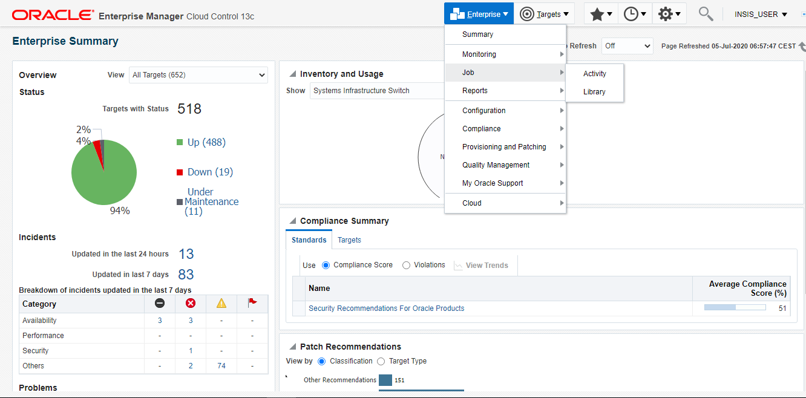

Step2:
Select CREATE JOB as per below screenshot.

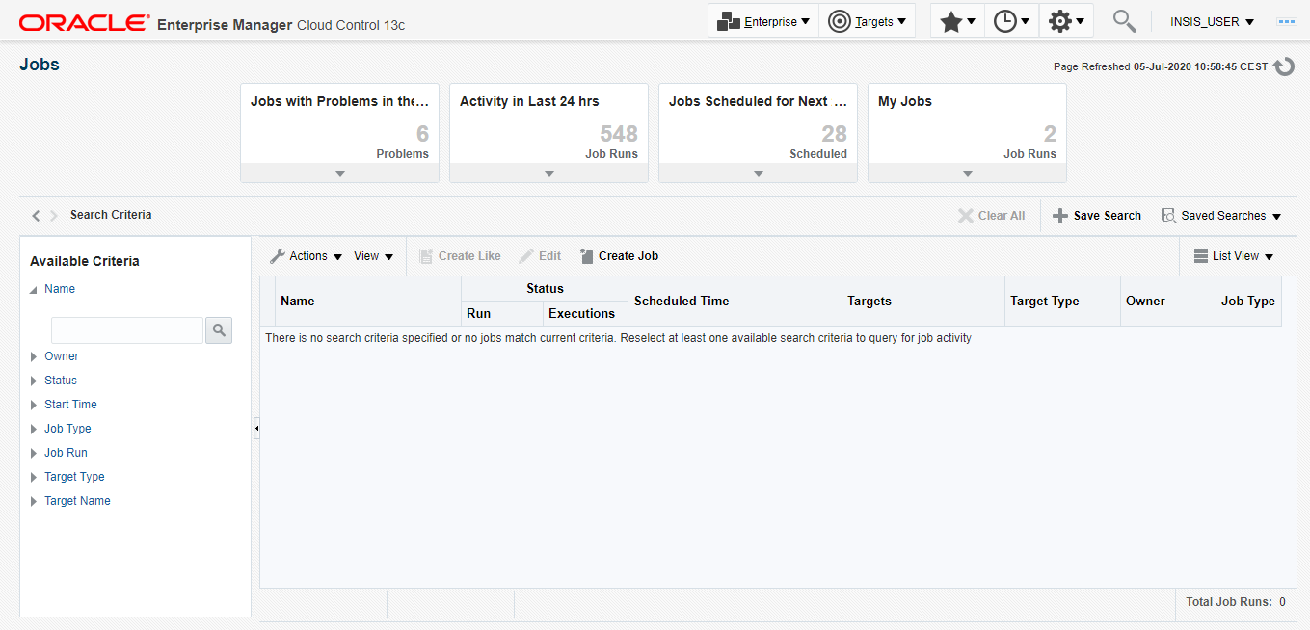

Step3:
Select the job type of the script that will scheduled on the servers, here I have selected OS COMMAND.
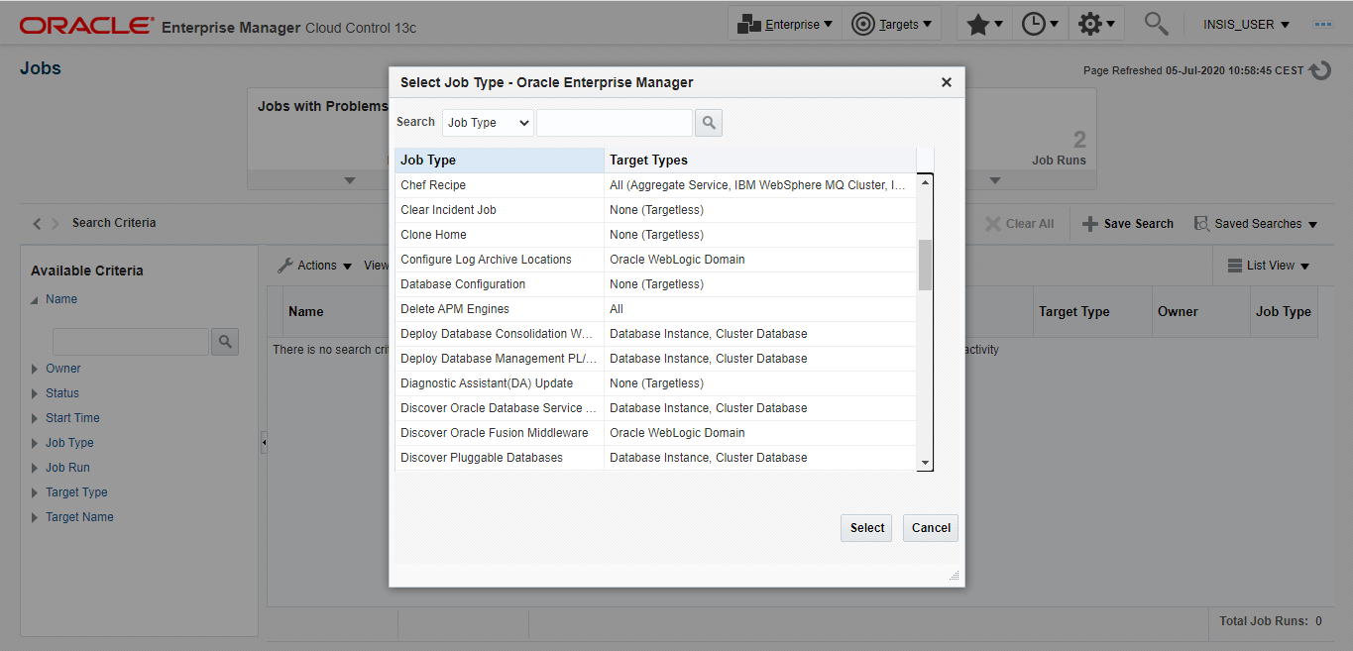
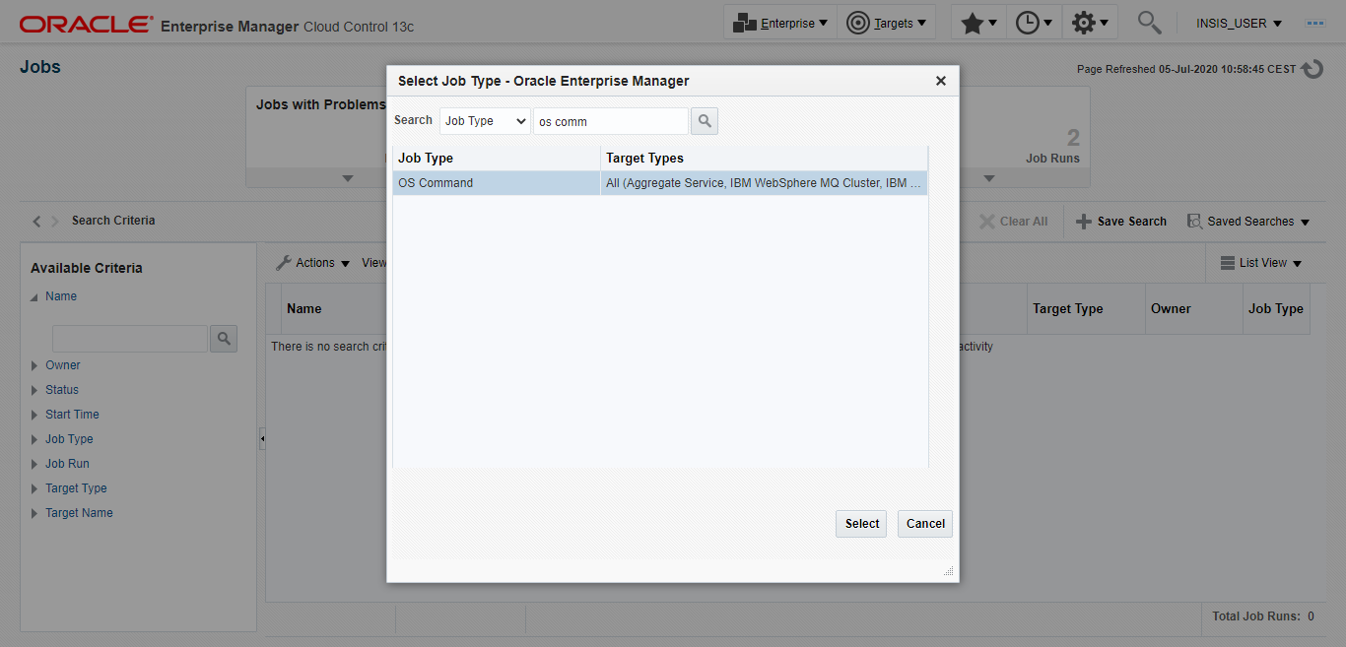
Step4:
In General Tab, we need to provide the Name for the job, set the number of Automatic attempts and time period between the attempts, also add the Server where the script going to be scheduled.

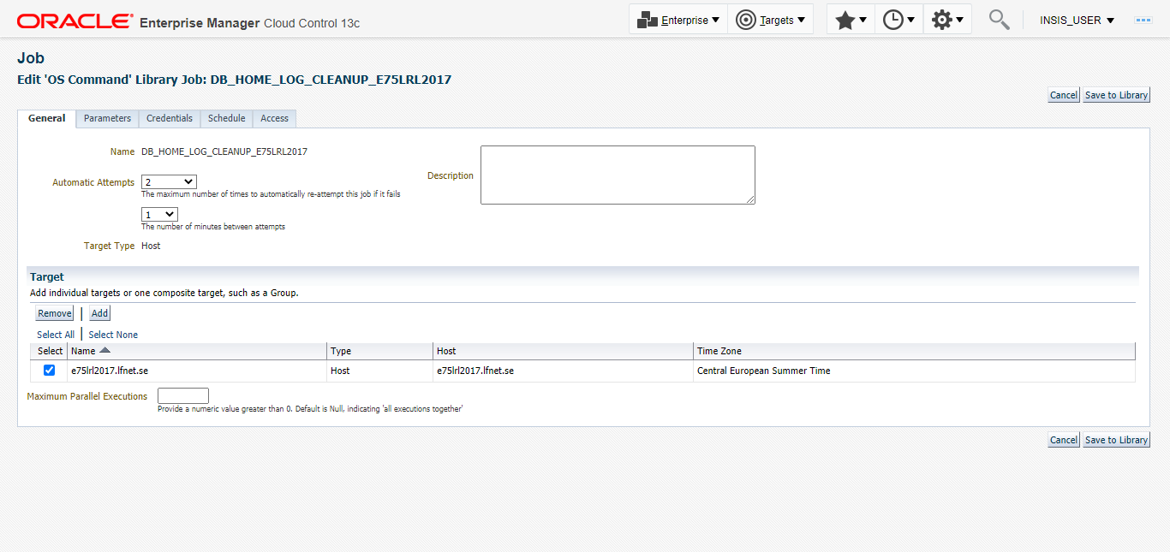

Step5:
In Parameters tab, we need update the Command Type and provide the full script that needs to be scheduled in the job.
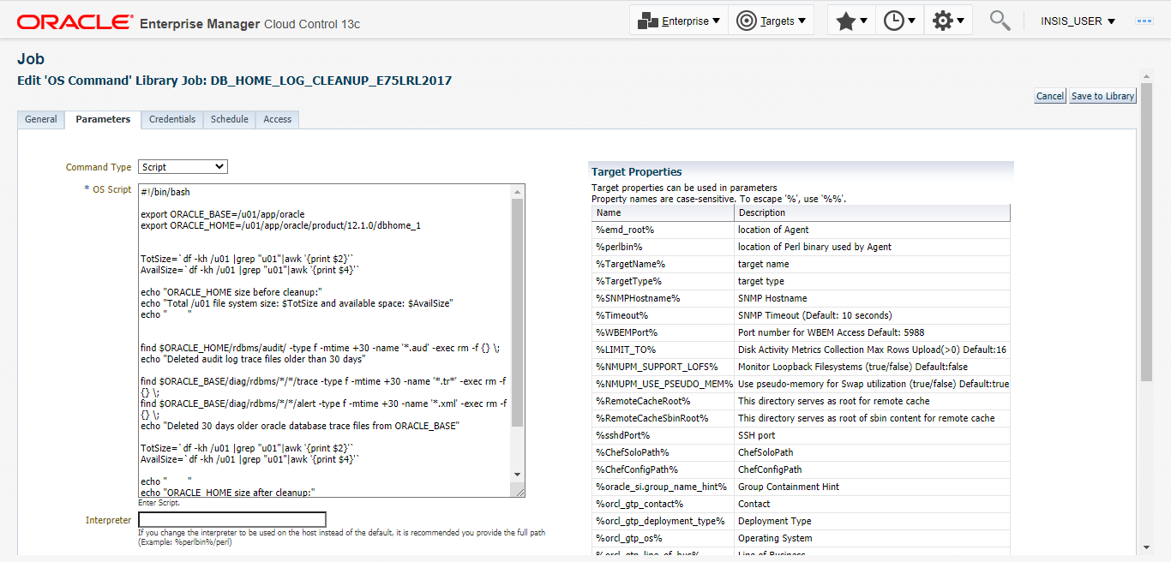
Step6:
In Credentials tab we need to provide the credential to login the server and it also can be saved for other jobs.
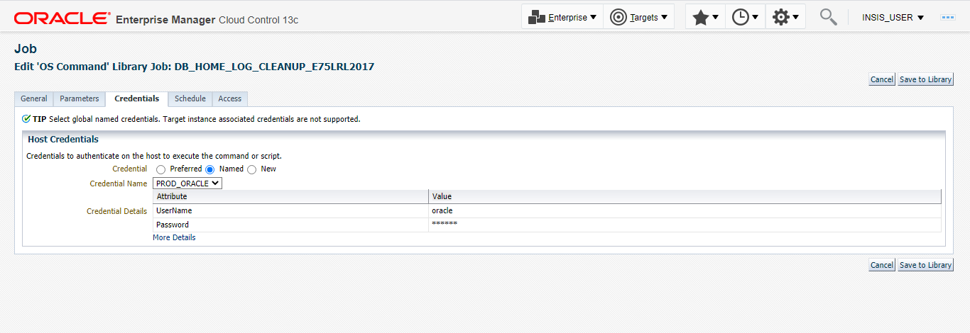
Step7:
In Schedule Tab, we need to provide all the details of the Job, that it should run one time or repeating, also need to set how frequently it will run and submit the details.
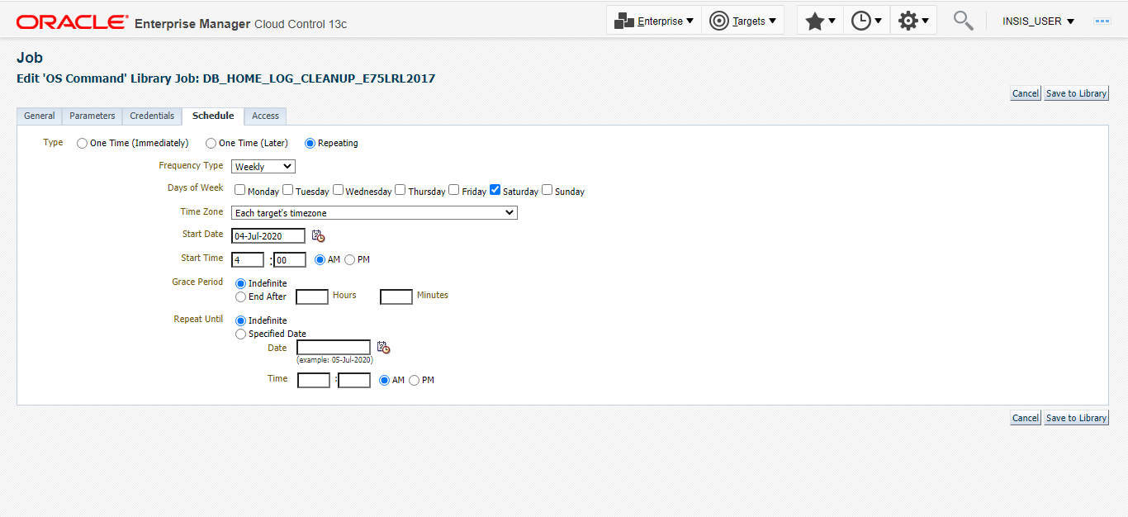

5: Ouput Log:
5.1 OUTPUT LOG OF DB_HOME_LOG_CLEANUP SCRIPT
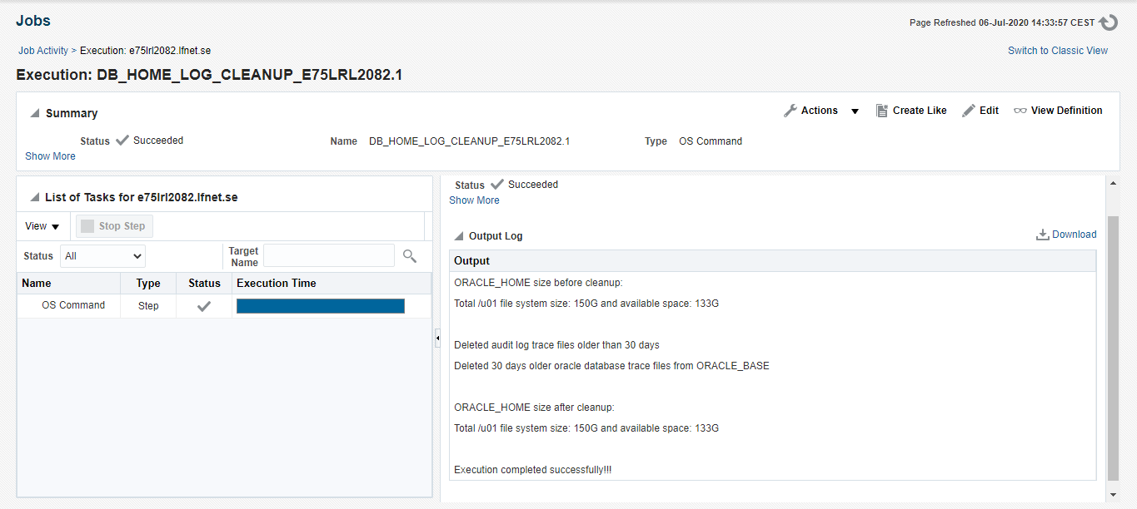

5.2 OUTPUT LOG OF aLERT_LOG_FILE_ROTATION SCRIPT
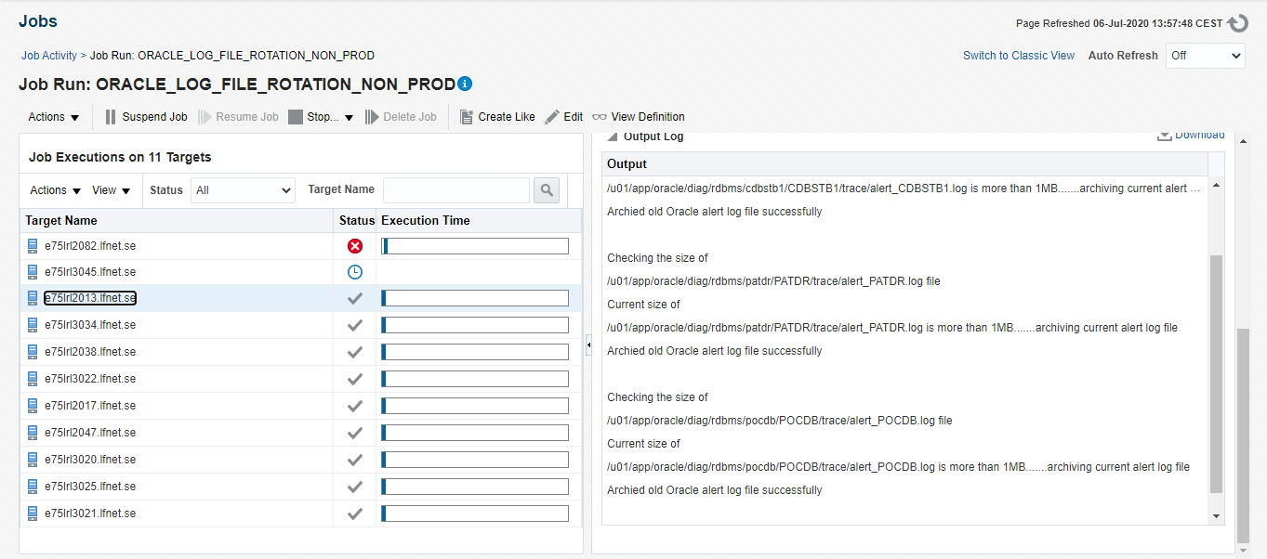

** These mentioned steps are tried & tested. In case of any random issues, investigate the issue properly and take appropriate action. Happy Learning!!!!!!

END OF DOCUMENT

